Geography

Models

and

Concepts

Cr. Miami Beach Senior High School geography models and concepts list.
1. Demographic Transition Model 3
2. Gravity Model 4
3. Zelinsky (perceptual regions) 4
4. North American Urban Models: 4
5. Sector Model (Hoyt) 6
6. Multiple Nuclei Model (Harris & Ullman) 6
8. Models of Industrial Location 7
(Least - Cost Theory= by Weber) 7
9. Joel Garreau-- The Nine Nations of North America (1981) 9
10. von Thunen's Model (Agricultural) 10
11. Epidemiologic Transition Model (based on health/welfare of a country) 11
12. World Systems Analysis a.k.a: Core Periphery Model (Wallerstein) 12
13. Heartland (MacKinder) and Rimland (Spykman)Theories 12
14. Neocolonialism 13
15. Thomas Malthus (Population) 14
16. Stages of Development (Rostow: ladder of development) 15
15. Organic Theory (Ratzel) 15
16. Bid-Rent Theory 16
17. Rank Size Rule 16
18. Carl Sauer (cultural landscape & domestication) 17
19. Ravenstein: laws of migration 17
20. Renfrew Hypothesis, Dispersal Theory, Conquest & Agricultural Theory 18
(Diffusion of P.I.E. Language) 18
21. Marija Gimbutas (1921-1944) – The Kurgan Hypothesis (1950s) 19
22. Global Urban Models: 19
23.Africa= N/A 20
24. SE Asia= McGee 21
25. Koppen Climate System 24
26. Jared Diamond’s “Geographic Luck” 25
27. Agricultural Hearths 26
28. World Religions 27

Demographic Transition Model

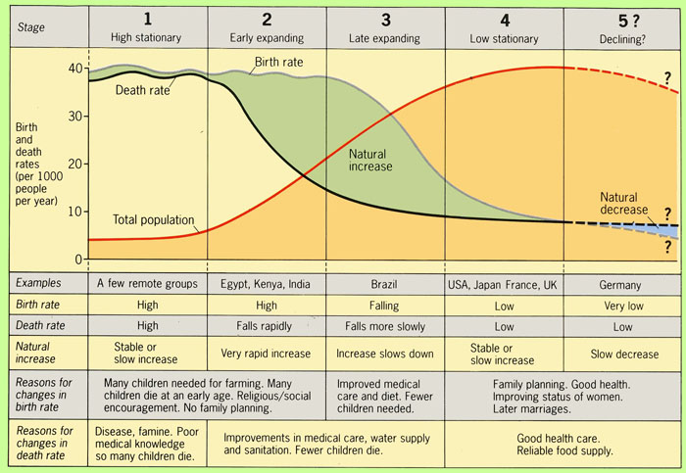

Stage 1: Low Growth (high CBR&CDR, low NIR)
Stage 2: High Growth (high CBR&NIR, low CDR) (happened due to industrial revolution)ex:Cape Verde, Nicaragua
Stage 3: Moderate Growth(decreasing CBR,CDR,NIR)(happens when people decide to start having less kids) ex:Chile,
Stage 4: Low Growth(CBR=CDR, has ZPG) ex: USA, England, Luxemburg
Stage 5: Unofficial stage (low CBR, increasing CDR) ex: Russia

2. Gravity Model

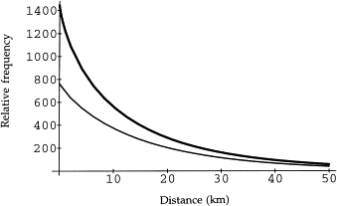
Distance and population size effect receiving and sending countries
-people will travel closer than far but large populations send more people.
e.g. China and India have large populations and therefore send people to the US

3. Zelinsky (perceptual regions)
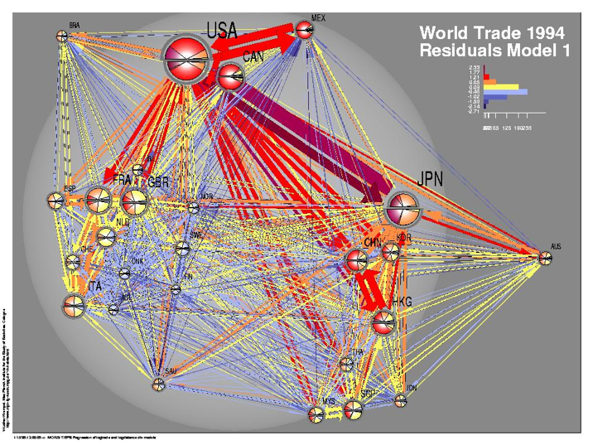
Zelinsky was student of Carl Sauer; a cultural geographer who, for six decades, has been an original and authentic voice in American cultural geography.

4. North American Urban Models:

--Concentric Circle (Burgess)
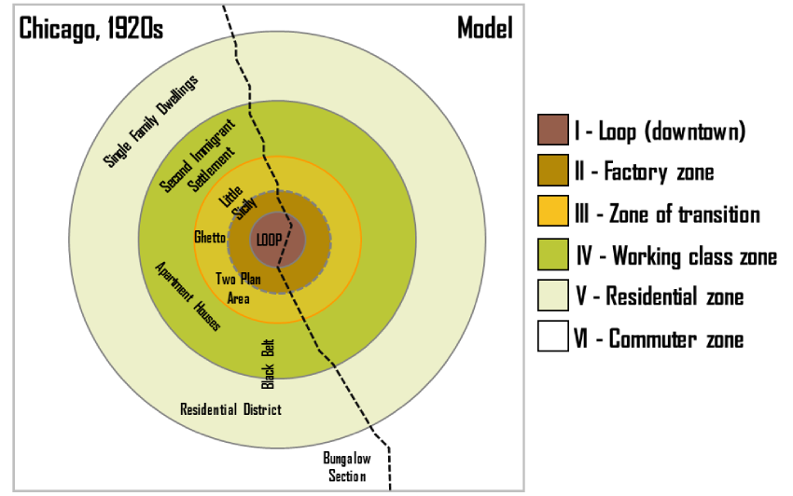
Concentric Zone Model (1925, E.W. Burgess): structural model of the American central city (based on Chicago in the 1920s). Burgess's work is based on bid rent - the amount that people will pay for the land (e.g., wealthier families tended to live much further away from the CBD; could afford automobiles).
1st Inner ring-CBD
2nd Transition Zone (poorer, immigrants)
3rd Working Class Homes
4th Newer spacious homes
5th Commuters
Criticisms:
- First, the model does not work well with cities outside the United States, in particular with those developed under different historical contexts. Even in the United States, because of changes such as advancement in transportation and information technology and transformation in global economy, cities are no longer organized with clear "zones"
- It describes the peculiar American geography, where the inner city is poor while suburbs are wealthy; the converse is the norm elsewhere.
- It assumes an isotropic plane – an even, unchanging landscape.
  - Physical features – land may restrict growth of certain sectors; hills and water features may make some locations unusually desirable for residential purposes.
- Commuter villages defy the theory, being a distant part of the commuter zone.
- Decentralization of shops, manufacturing industry and entertainment.
- Urban regeneration and gentrification – more expensive property can be found in formerly 'low class' housing areas.
- Many new housing estates were built on the edges of cities in Britain.
- It does not address local urban politics and forces of globalization.

5. Sector Model (Hoyt)

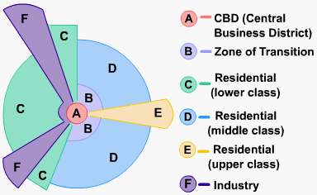
Sector Model (1939): improvements in transportation made the Burgess Model more obsolete. Hoyt observed that zones expanded outward from the city center along electric trolley lines, railroads, highways, and other transportation arteries; wedge-shaped patterns -- or sectors -- emanating from the CBD and centered on major transportation routes instead of rings.

6. Multiple Nuclei Model (Harris & Ullman)
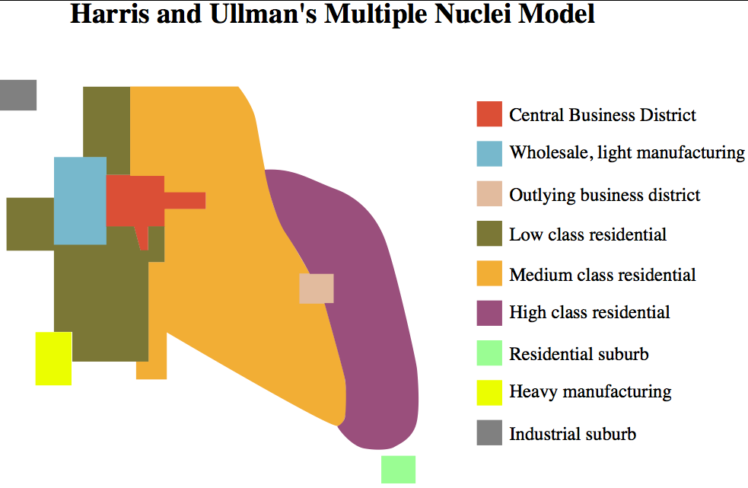
Multiple Nuclei Model (1945, E.L. Ulman): based on the idea that people have greater movement due to increased car ownership. This increase of movement reduced the primacy of the CBD and allowed for the specialization of regional centers (e.g., nuclei such as light manufacturing or business parks). Cities are a complex structure w/ more than 1 center also says certain things are more attracted to certain areas
ex: airports attract hotels and universities attract pizzerias.

7. Central Place Theory (Christaller)

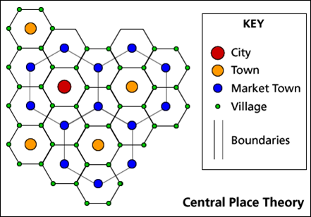
Central place theory (1933): designed to explain the spatial distribution of human settlements. Central places are settlements providing services to their surrounding “market areas”. The ordering of settlements based on the number and level of services they provide produces a hierarchy( city, town, village, hamlet). where central places in the urban hierarchy would be functionally and spatially distributed (hexagon shaped areas). It also assumes that all land is the same (equal, no valleys mnts)
e.g. Iowa

8. Models of Industrial Location

(Least - Cost Theory= by Weber)
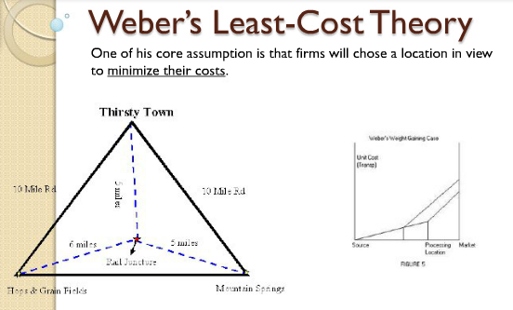
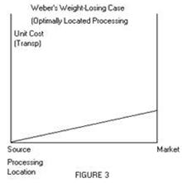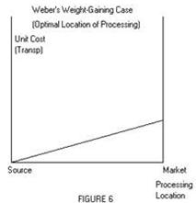

Least Cost Theory (1940s): owners of manufacturing plants seek to minimize three costs: 1) transportation, 2) labor, and 3) agglomeration (too much can lead to high rents & wages, circulation problems – and ultimately to deglomeration); in the weight-losing case, firms locate closer to the raw materials to reduce cost; in the weight-gaining case, firms locate closer to the market.

Criticisms:
1. Unrealistic Assumptions:
He has not given due to place to the type of transport, quality of goods to be transported, topography, character of region etc.
2. Labour Centres Notion Defective:
He has started with the presumption that there are fixed labour centres with unlimited supplies of labour in each of them, however, there cannot be fixed labour centres, because each industry creates new labour centres and there is no unlimited labor.
3. Ideas about Fixed Points of Consumption:
Consumers are always scattered all over the country and thus consumer centres always shift with a shift in industrial population so there is no fixed point of consumption.
4. Vague Generalisations:
There are certain historical and social forces which go a long way while deciding industrial location of an industry, but he has completely ignored them.
6. Defective Method of Analysis:
Weber has tried to classify material into ubiquities and fixed material. Again the division is arbitrary. According to Robinson who does not know that in actual practice materials are drawn from a large number of alternative fixed points.

9. Joel Garreau-- The Nine Nations of North America (1981)

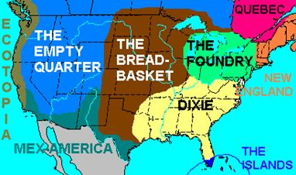
The Nine Nations of North America (1981); Garreau argues that North America can be divided into nine regions, or "nations", which have distinctive economic and cultural features; he contends that conventional national and state borders are largely artificial and irrelevant, and that his "nations" provide a more accurate way of understanding the true nature of North American society. In 1991, Garreau discussed the development of edge cities as autonomous loci of economic activity on the urban fringe of US cities away from the CBD.
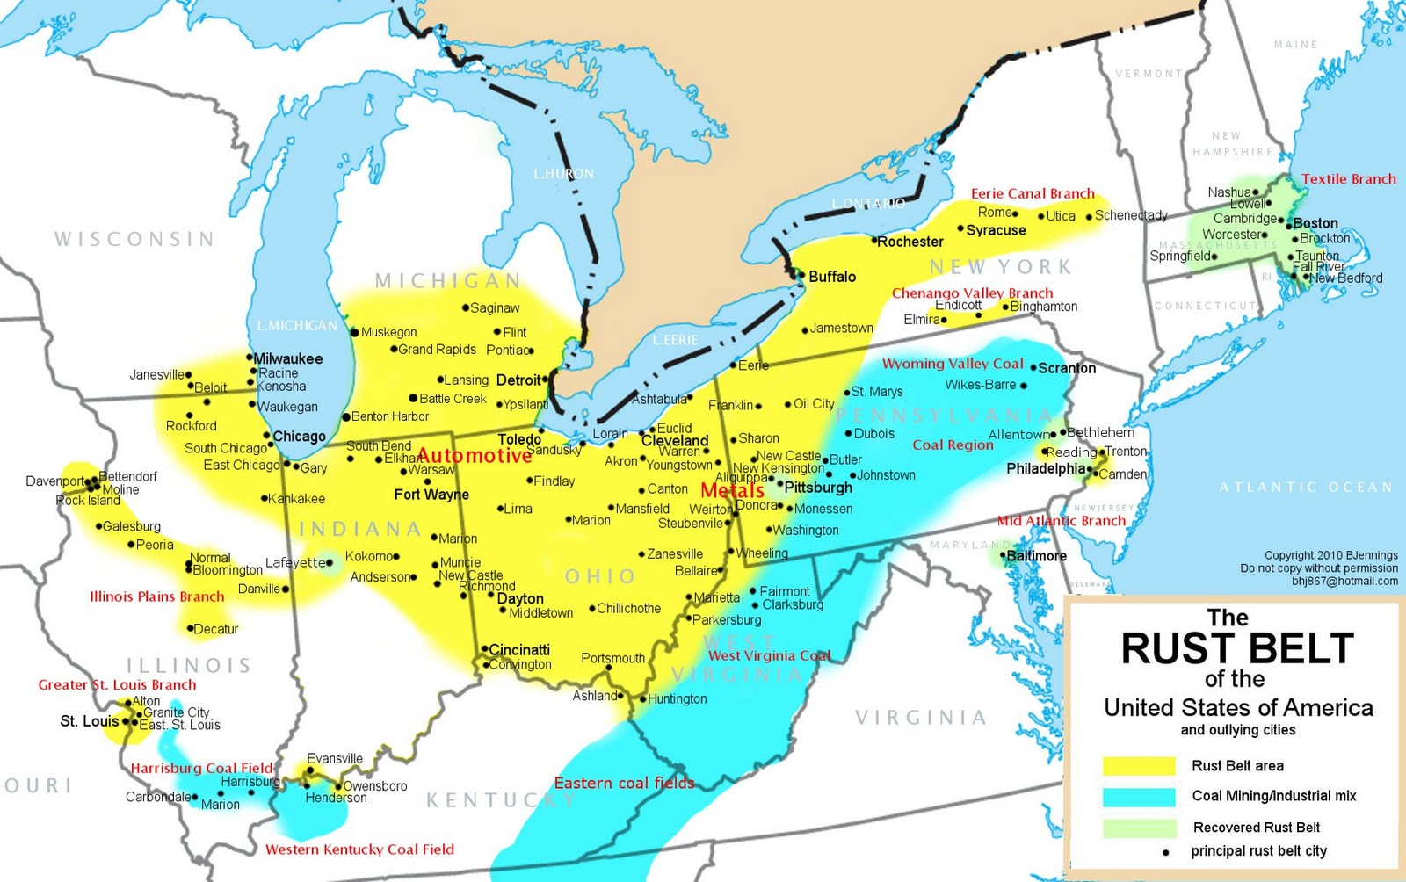

10. von Thunen's Model (Agricultural)
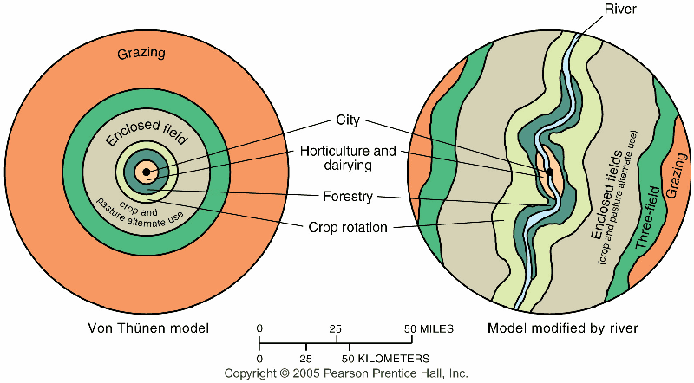

Discussed agricultural location as primarily a factor of transportation cost and profit maximization by farmers through his model. For the image to the left - the black dot represents a city; 1 (white) dairy and market gardening; 2 (green) forest for fuel and building materials; 3 (yellow) grains and field crops; 4 (red) ranching; the outer, dark green area represents wilderness where agriculture is not profitable.
1. takes into account cost of tranportation (which governs use of land)
2. assumes no natural features (land uniformity)
3. model places market in middle surrounded by dairy, then forestry (lumber), thengrains and field crops, and lastly ranching and livestock

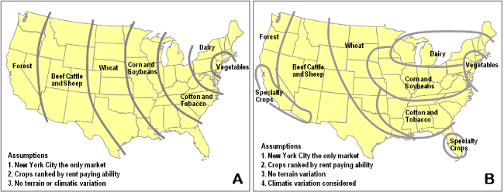

11. Epidemiologic Transition Model (based on health/welfare of a country)

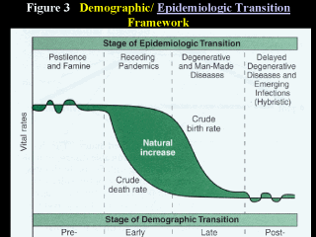
Stage I: Pestilence and Famine Infectious and parasite diseases were principle causes of death along with accidents and attacks by animals and other humans. Thomas Malthus called these caused of death “natural checks” Most violent Stage I epidemic was the Black Plague(bubonic plague or black death) probably transferred to humans by fleas from infected rats
Stage II: Receding Pandemics Improved sanitation, nutrition, and medicine during the Industrial Revolution reduced the spread of infectious diseases. Death rates did not improve immediately and universally during the early years of the Industrial Revolution. Poor people who crowded into Industrial Cities had high death rates due to Cholera
Stage III: Degenerative Diseases Associated with the chronic diseases of aging Heart disease and cancer Sub-Saharan Africa and South Asia have low incidences of cancer primarily because of low life expectancy.
Stage IV: Delayed Degenerative Life expectancy of older people is extended through medical advances. Cancer medicines, bypass surgery, better diet, reduced use of tobacco, and alcohol However, consumption of non-nutritious food and sedentary behavior have resulted in an increase in obesity in this stage.
Stage V: Return of Infectious Disease Return of Stage I diseases (Malaria, SARS, TB, AIDS) Caused by: θ Travel θ Poverty θ Evolution of microbes

12. World Systems Analysis a.k.a: Core Periphery Model (Wallerstein)

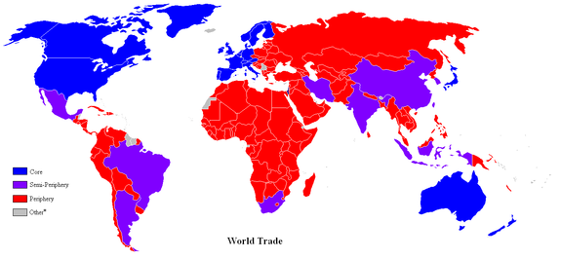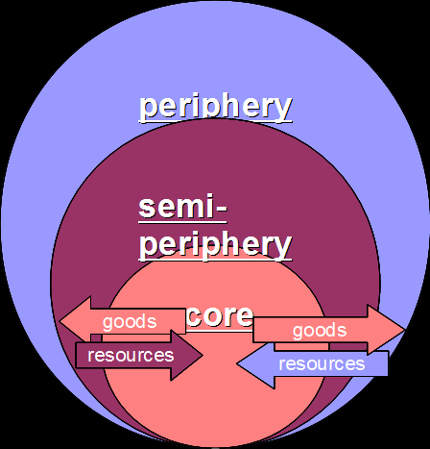

World Systems Theory (1974-89): proposed a three-tier structure to a “one-world” economic and political structure; it is a dependency model, “countries do not exist in isolation but are part of an intertwined world system”.
the "core" (industrialized capitalist countries – US, UK, Japan)
the "semi-periphery" (industrializing – Brazil, China, India)
"periphery" (undeveloped or developing – Congo, Zambia, Haiti)
Criticisms:
- It downplays the role of culture. For example it focuses heavily on U.S economic influence but it pays little attention to the pervasive influence of the U.S culture.
- It is somewhat outdated
- It is of little practical use
- It fails to recognize the role of nongovernmental organizations.

13. Heartland (MacKinder) and Rimland (Spykman)Theories

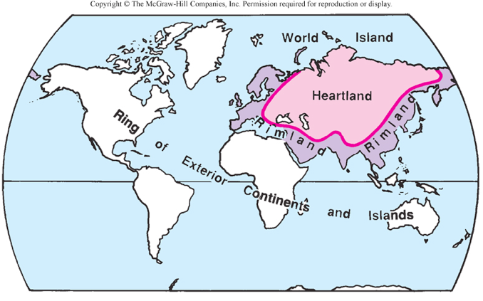
Heartland Theory (1904): the resource-rich, land-based “pivot area” (Heartland) would be key to world dominance (controlled by the USSR at that time; diametrically opposed to Mahan’s contention of sea power;
"Who rules East Europe commands the Heartland;
Who rules the Heartland commands the World-Island;
Who rules the World-Island controls the world."
Rimland Theory (1944): the Eurasian Rimland, not the Heartland would be key to global power; the Rimland would be important in containing the Heartland; Britain, US and USSR would be the main power players; engendered NATO in 1949 which was President Harry Truman’s policy on containing communist expansion.
Who controls the rimland rules Eurasia;
Who rules Eurasia controls the destinies of the world.
- *Spykman is known as the “godfather of containment”

14. Neocolonialism
Seeking out the regional culture and reinvigorating it in response to the uncertainty of the world.

15. Thomas Malthus (Population)

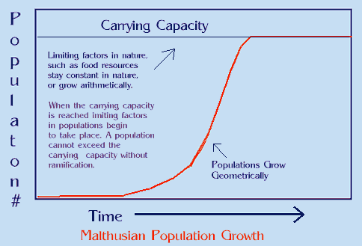

Gave a dystopian (not Utopian) view of the future (1798); food production increases arithmetically, whereas human reproduction increases geometrically (J curve - doubling each generation); despite checks on population (e.g., plague, famine) there would continue to be starvation.

Esther Boserup
In 1965, Boserup discussed that population growth stimulates intensification in agricultural development (stimulates technology) … rather than being increased by agricultural output (Malthus upside-down); the rate of food supply may vary but never reaches its carrying capacity because as it approaches the threshold, an invention or development increases food supply, however, the depletion of nutrients creates diminishing returns. (S- curve – levels off after it reaches carrying capacity)

16. Stages of Development (Rostow: ladder of development)
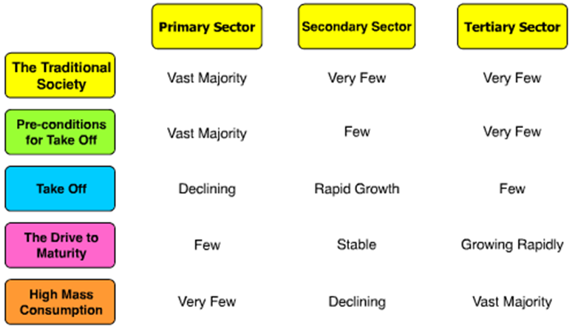
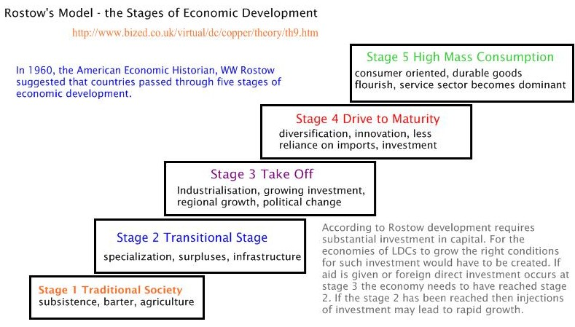

Criticisms:
- Focused on white man’s countries and did not fit non-western/capitalist countries.
- The model encouraged exploitation of less developed countries
- Focused itself in the direction of progress, however countries might need assistance, money and technology of developed countries in order to develop.
- Differences exist between countries: physical size population, natural resources, relative location and political systems.
- Failed to recognize sustainable development nor the carrying capacity of the Earth.
- Failed to realize that most countries reached stage of high mass consumption by exploiting the resources of lesser developed countries.

15. Organic Theory (Ratzel)

German geographer who discussed geopolitics (1901) and more specifically, lebensraum (“living space”). Ratzel’s organic theory postulated that a country, which is an aggregate of organisms (people), would itself function and behave like an organism … to survive, a state requires nourishment – in the global context, this means territory – to gain political power. (Hitler)

16. Bid-Rent Theory
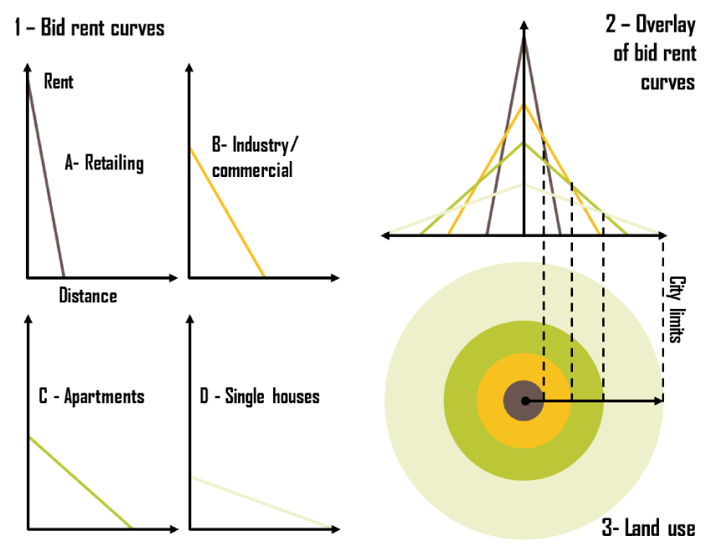
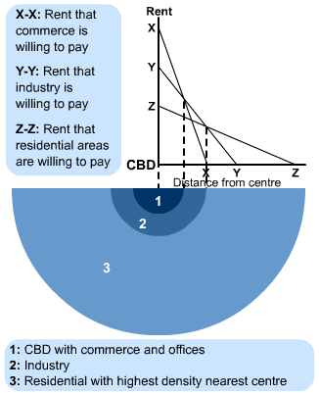

17. Rank Size Rule
- Rank-Size Rule
- When cities are rank-ordered from largest to smallest, the "rank-size rule" says that the r-th largest will be 1/r-th the size of the largest city, i.e., rank-times-size is a constant equal to the size of the largest city. The equation is

FIG. 9-3c. RANK-SIZE PLOT, U.S. CITIES OVER 100,000, 1980
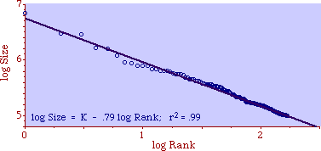
Criticisms:
The model is based on the United states, however in other countries there are primate cities which hold more than half of the county’s population.

18. Carl Sauer (cultural landscape & domestication)

Sauer discussed cultural geography; fierce critic of environmental determinism, his ideas supported cultural ecology. (Cultural ecology is the study of human adaptations to social and physical environments. )

19. Ravenstein: laws of migration
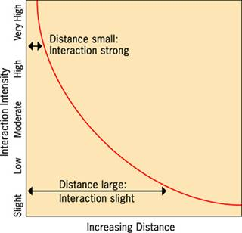
Laws of migration (1885):
1) Net migration amounts to a fraction of the gross migration.
2) The majority of migrants move a short distance.
3) Migrants who move longer distances tend to choose big-cities.
4) Urban residents are less migratory than inhabitants of rural areas.
5) Families are less likely to make international moves than young adults.
Gravity model: (shown to the left) interaction is proportional to the multiplication of the two populations divided by the distance between them; this phenomenon is distance decay (the effect of distance on cultural or spatial interactions).

20. Renfrew Hypothesis, Dispersal Theory, Conquest & Agricultural Theory (Diffusion of Proto Indo-Europeam Language)
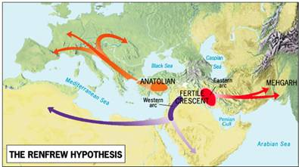
The Anatolian Hypothesis (1987) states the P-I-E language spread through the innovation of agriculture rather peacefully with Anatolia (modern day Turkey) as the hearth.

21. Marija Gimbutas (1921-1944) – The Kurgan Hypothesis (1950s)
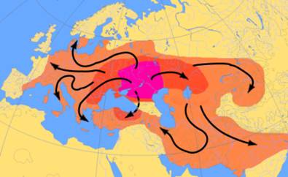
Introduced the Kurgan Hypothesis (1950s), which states the Proto-Indo-European language diffused from modern day Ukraine through conquest.

Global Urban Pattern Models

22. Latin American= Griffin-Ford

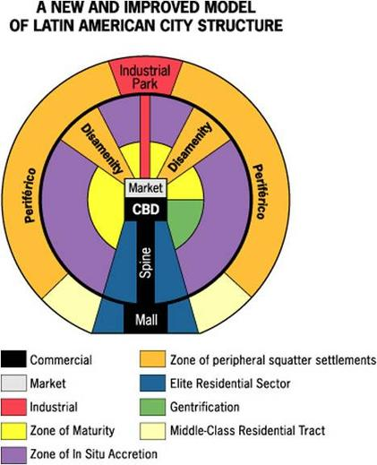
The Latin American City Model combines elements of Latin American Culture and globalization by combining radial sectors and concentric zones.

Clarifications:
Disamenity: slums.
Spine: High income residents reside on either side of the spine.
The Mall and the industrial park are decentralized nodes.

23.Africa= N/A

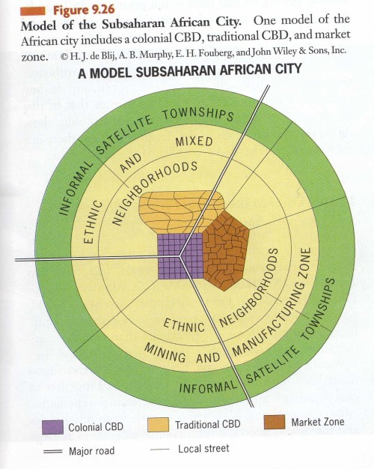

24. SE Asia= McGee

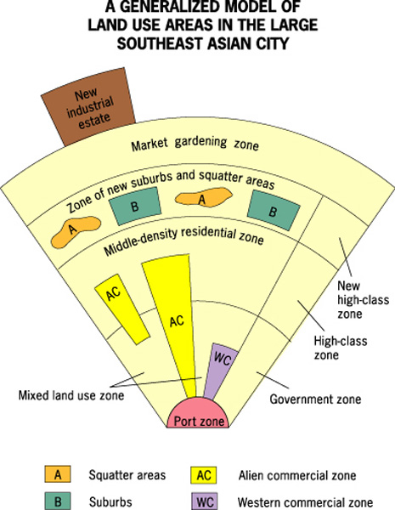
-This model was developed in 1967 by T.G. McGee. It is sometimes called the McGee Model.
- As the model shows, no CBD is visible. However, several components of the CBD are present in separate areas in the city. Basically the components of the CBD are clustered around the port zone. The Western commercial zone for western businesses. The alien commercial zone is dominated by the Chinese who have migrated to other parts of Asia and live in the same buildings as their businesses. These are Chinese merchants. And then there is the mixed land-use zone that has miscellaneous activities including light industry. There is also a separate area known as the government zone near the center of the model. Also note the mixed- land use zone contains various economic uses which can include informal business.
-The focal point is the Port Zone reflecting a city oriented around exporting.
Key Concepts:
-The Southeast Asian City Model is similar to the Latin American (Griffin-Ford) City Model in that they each feature high-class residential zones that stem from the center, middle-class residential zones that occur in inner-city areas, and low-income squatter settlements that occur in the periphery.
- The main difference between the two models is that the Southeast Asian City Model features middle-income housing in suburban areas. This reflects the larger percentage of middle-class citizens that reside in the peripheral regions than those of Latin America.
Examples of the model:
Kuala Lampur, Malaysia, Jakarta, Indonesia

25. Koppen Climate System

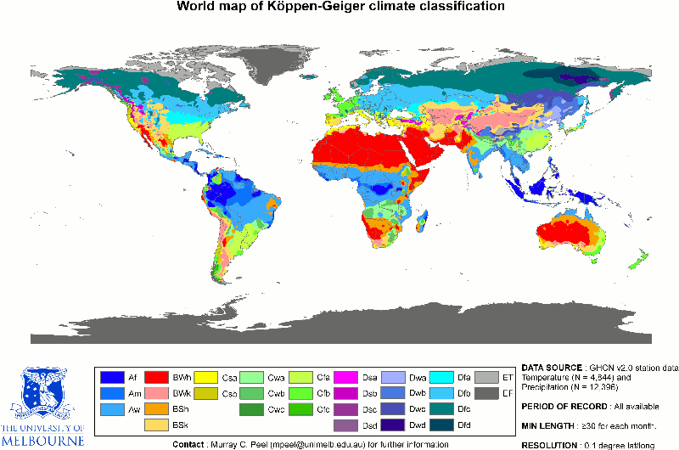
Köppen system contains up to three levels of sorting.
A - Tropical Moist Climates: These are very warm climates found in the tropics that experience high quantities of precipitation. The primary distinguishing characteristic of these climates is all months have average temperatures above 18°C (64°F).
B - Dry Climates: These are climates that experience little precipitation during most of the year. Further, potential losses of water from evaporation and transpiration greatly exceed atmospheric input.
C - Moist Mid-latitude Climates with Mild Winters: In these climates, summer temperatures are warm to hot and winters are mild. The primary distinguishing characteristic of these climates is the coldest month has an average temperature between 18°C (64°F) and -3°C (27°F).
D - Moist Mid-Latitude Climates with Cold Winters: In these climates, summer temperatures are warm and winters are cold. The primary distinguishing characteristic of these climates is the average temperature of warmest month exceeds 10°C (50°F), and average temperature of coldest is below -3°C (27°F).
E - Polar Climates: These climates have very cold winters and summers, with no real summer season. The primary distinguishing characteristic of these climates is the warmest month has an average temperature below 10°C (50°F).
H - Highland Climates: These are climates that are strongly influenced by the effects of altitude. As a result, the climate of such locations is rather different from places with low elevations at similar latitudes.

26. Jared Diamond’s “Geographic Luck”

- Guns, Germs, and Steel (1997); geographic luck (environmental determinism)

- Indo-European Language Tree

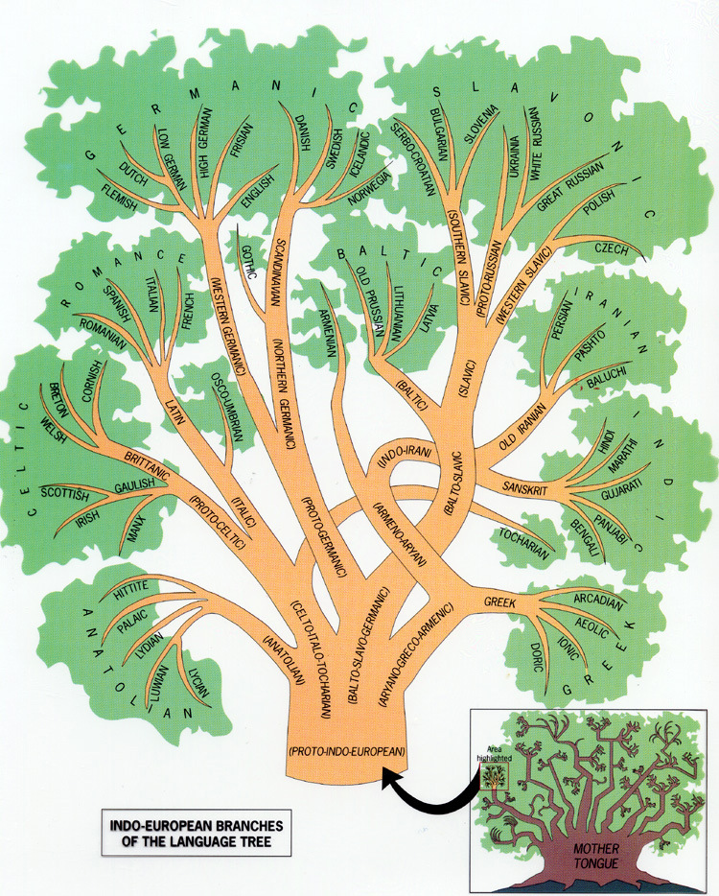

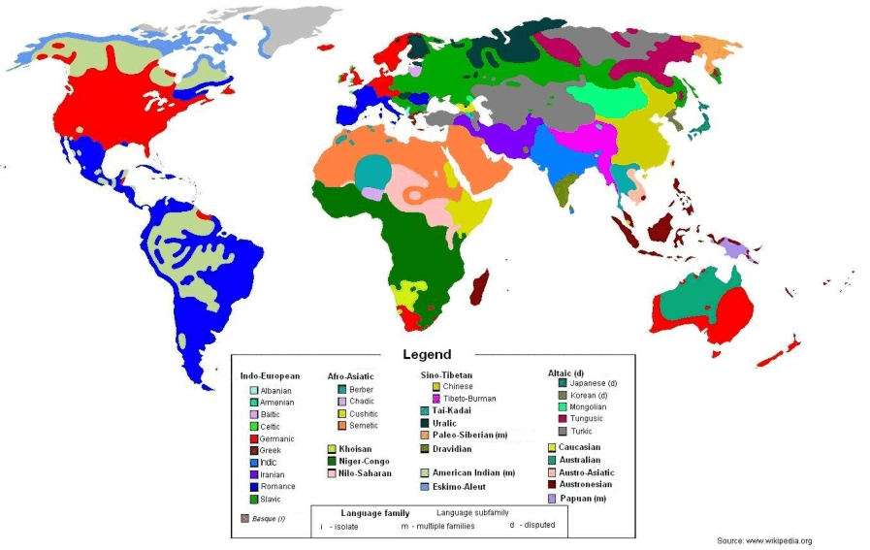

27. Agricultural Hearths

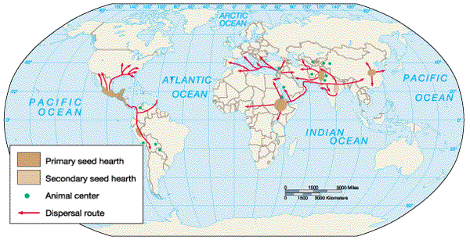

World Religions

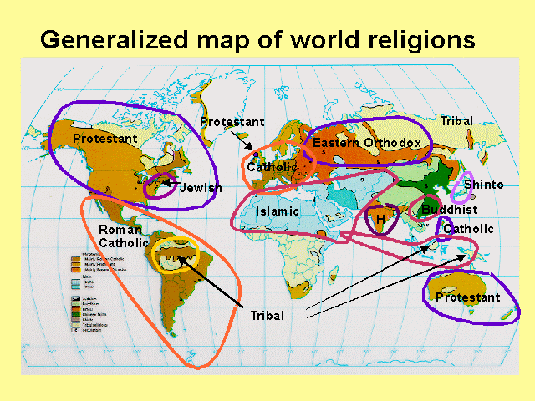

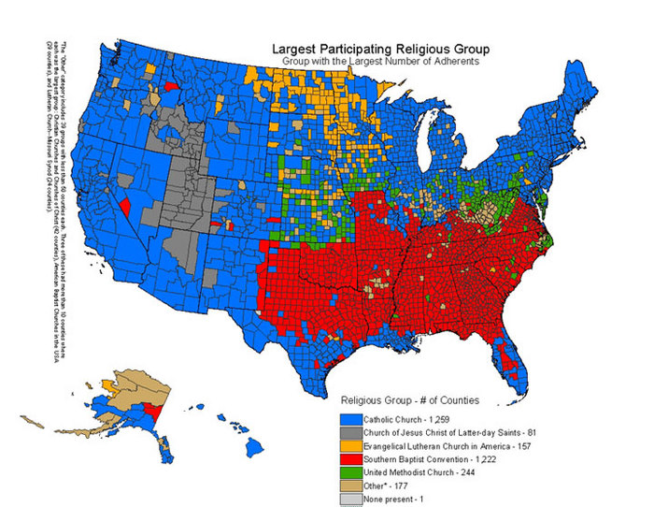

- Economic Sectors
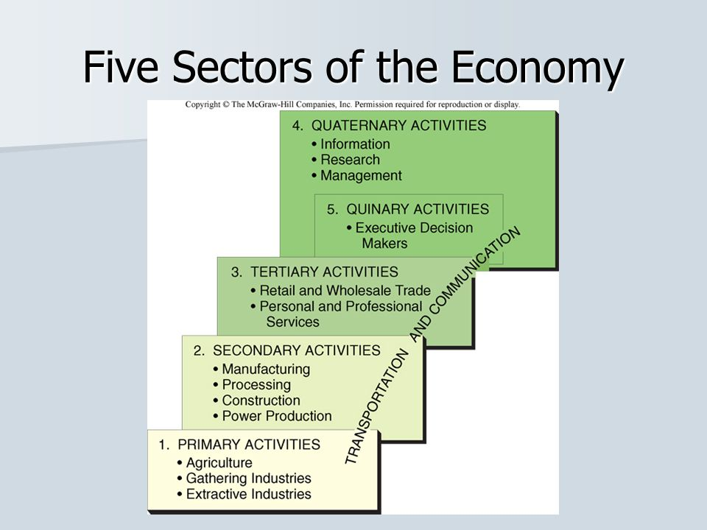

David Palmer, AMSCO Human Geography preparation for the Advanced Placement Examination ( I did not steal one from Mr. Buy’s classroom)
David Palmer, AMSCO Human Geography preparation for the Advanced Placement Examination ( I did not steal one from Mr. Buy’s classroom)

